DECISION TABLE

* The decision table consists of a set of conditions to evaluate and results to be returned
* It can be delegated to business users.
* These are fundamental to enforcing business decisions.
* It is based on properties and the value is specified based on the condition.
* It is like a tabular structure which consists of rows and columns.
* We can call a decision table from a decision tree by using the option “Allow selection of call decision option”, which will be there in the configuration tab.
* We can call the decision table from data transform using the below code

@DecisionTable.ObtainValue(tools, myStepPage, “StageCode”, True);

* We can call the decision table from :
* Flow
* Activity
* Data transform
* Decision Table
* Decision Tree
* Declare Expression
* Delegation Options

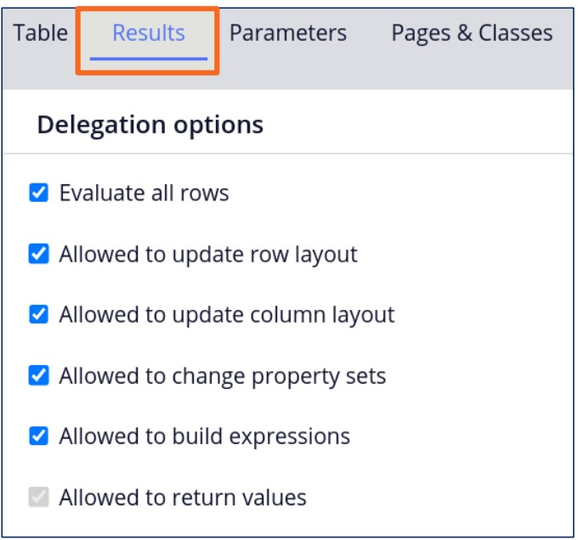

* Allowed to return values returns a single result.
* Evaluate all rows when we select this option all the below four rules will be selected as shown in the above diagram. And these rules can return multiple returns from decision table

1. Differences between the Decision table and Tree

A.

|  |  |
| --- | --- |
| Decision Table | Decision Tree |
| .Logic used is If, else if, else if… Otherwise | .Logic used is If, if, if , nested if… Otherwise |
| . Here the number of Properties for every logic is Fixed. | .Each logic can have different properties being used. |
| . We can use expression builder for properties, values and return results. | . We cannot use expression builder for return results. |
| .We can all other decision rules using only functions pxEvaluateDecsionTable, pxEvaluateDecsionTree, ObtainValue(). | . We can call other decision rule by selecting the under configuration tab “Allow Selection of Call decision option”. |
| We have Evaluate all rows option available | We don’t have evaluate all rows available. |

1. How to return multiple results using Decision Table
2. We can choose the options evaluate all rows under results tab of decision table.

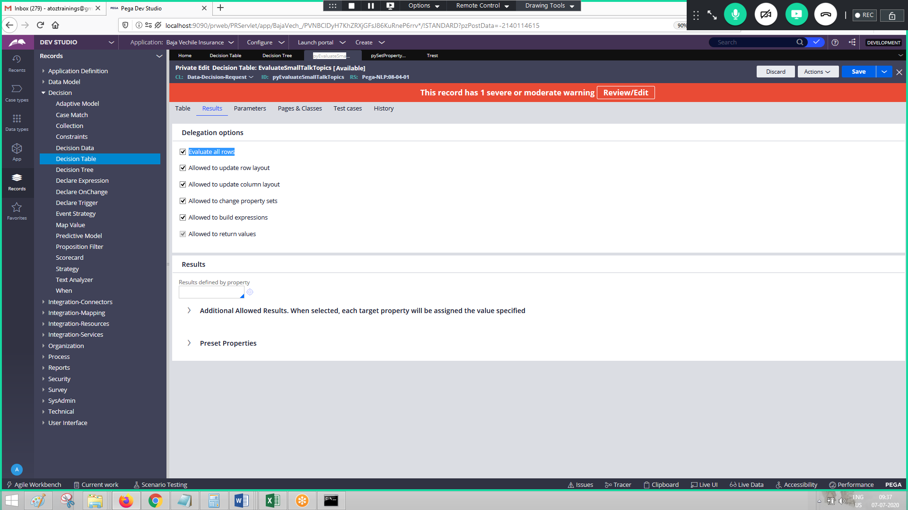

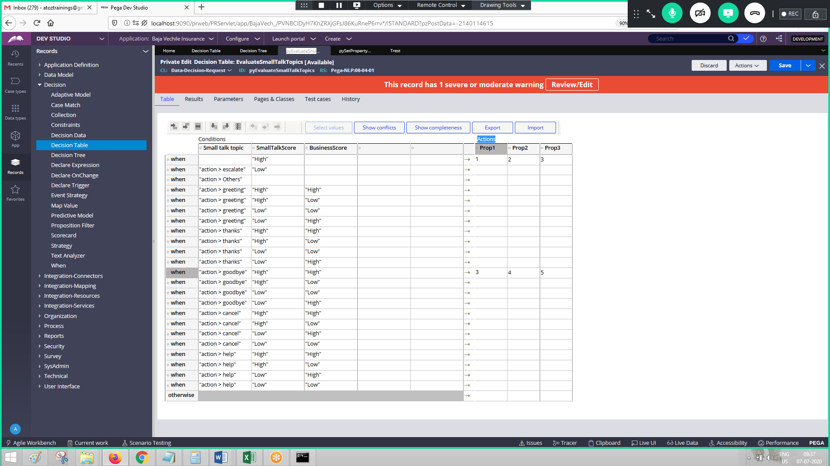

1. How do you decide whether to create decision table or Decision tree?

A. For all the condition if we have fixed properties then the Decision table. For each condition if we have different set of properties to be used, then decision tree.

1. How to call an activity for a decision table.
2. Using below functions CallActivity(pagename, activity name, parampagename), pxExecuteActivity(pagename, activity name)

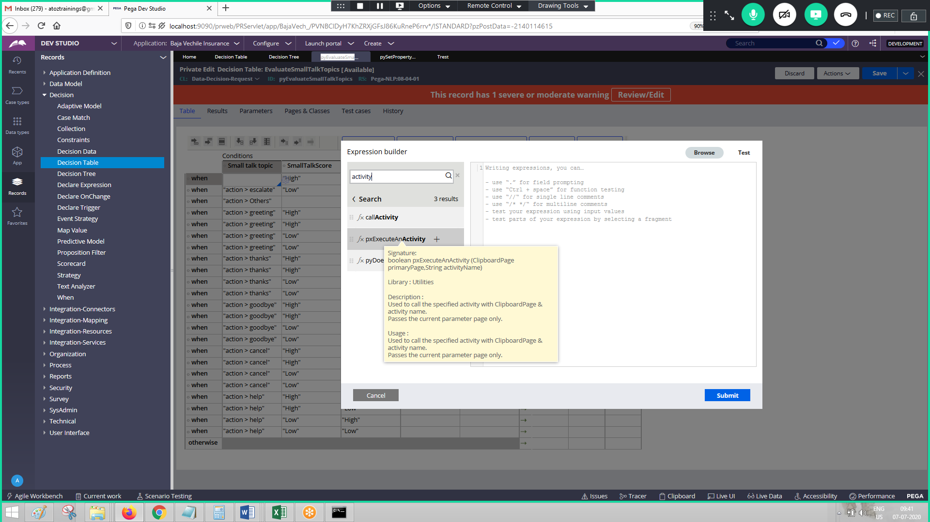

1. How to call decision table or tree from a DTF?

A Using Functions pxEvaluateDecsionTable, pxEvaluateDecsionTree, ObtainValue().

1. How to do exception handling in case of Decision table? OR What is “AllowMissingProperties” in activity method, Property-Map-DecisionTable?

A. By the time this table is called, PC expects all the properties that are involved in the conditions of DCT, to be available on the clipboard. Missing any of the properties from clipboard results into halting the program when the above option is not selected. Thus, Users may not be able to proceed forward.

If we select this option, missing properties will be ignored and conditions will be evaluated based only available properties.

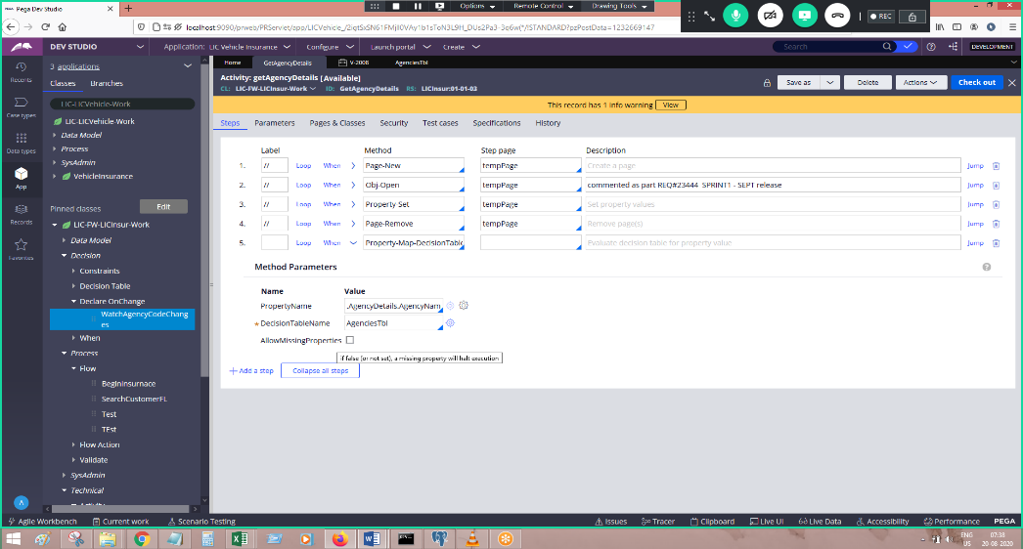

DECISION TREE

* It is a visual representation series of a tree structure.
* It is having a different set of properties and values for all the conditions.
* It evaluates multiple properties.
* It can return single or multiple results.
* It can be delegated.
* It is referenced in :
* Routers
* Flow rules
* Expressions
* It is having condition branches and nested branches.